**IE Compatibility Settings**

**Kindly request you to follow the below steps:**

1) Please remove PeopleSoft from IE favorites.

2) Clear cache, cookies, files, history, and SSL state

3) Close all IE sessions and try accessing PeopleSoft in a fresh Internet Explorer

**Check the below settings:**

1. Go to Internet Explorer-> ' Tools '-> Options ' ->Security->Click Local Intranet ' ->Click on Sites '-> Add all the three checkbox related to the Automatically detect intranet network
2. Click Advanced Button ' Add this URL' here: https://compass.learning.cognizant.com
3. Click on Tools >> Internet Options >> Connections tab >> LAN settings >> Proxy server >> Address: proxy.cognizant.com >> Port: 6050
4. Click on Advanced tab >> Exceptions >> Type 10.*;*.cognizant.com >> Click OK
5. Click on ALT + T (in keyboard) in your browser then select Compatibility View Settings and check Cognizant.com is already added or not, if not add it.
6. Check “Include updated website list from Microsoft”, check “Display Intranet sites in Compatibility view” and check “Display all websites in Compatibility View”. "

**To clear cache and Temporary internet files:**

1. Navigation: start>>Run>>(type)%temp%. In the temp folder, select all items and shift+delete
2. Navigation: In the top right corner of the IE window. Click on Tools >> Internet Options >> Delete Cookies and Temporary Files Delete >> Uncheck "Preserve Favorites Website Data" and click on delete.

**To remove POP-UP Blocker:**

1. Go to Internet Explorer-> Internet Options ->’Privacy’->Make sure “Turn on Pop-Up Blocker” check box is NOT CHECKED.

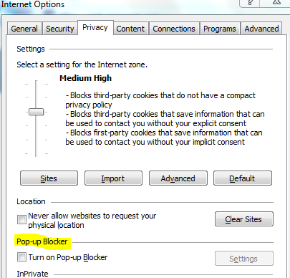

In a new browser, login to ELM (https://compass.learning.cognizant.com) and click "All Learning" tab where you can launch or check status of all courses.

**Launched in Chrome**

Please launch the course in "Chrome browser". Make sure that "POP UP Blocker" is turned OFF.

Try clearing cookies before you launch the course. If you still face issue while launching in CHROME browser, please attach the screenshot of issue page.